* * * Prattsburgh Winter Festival * * *
December 5th, 6th and 7th
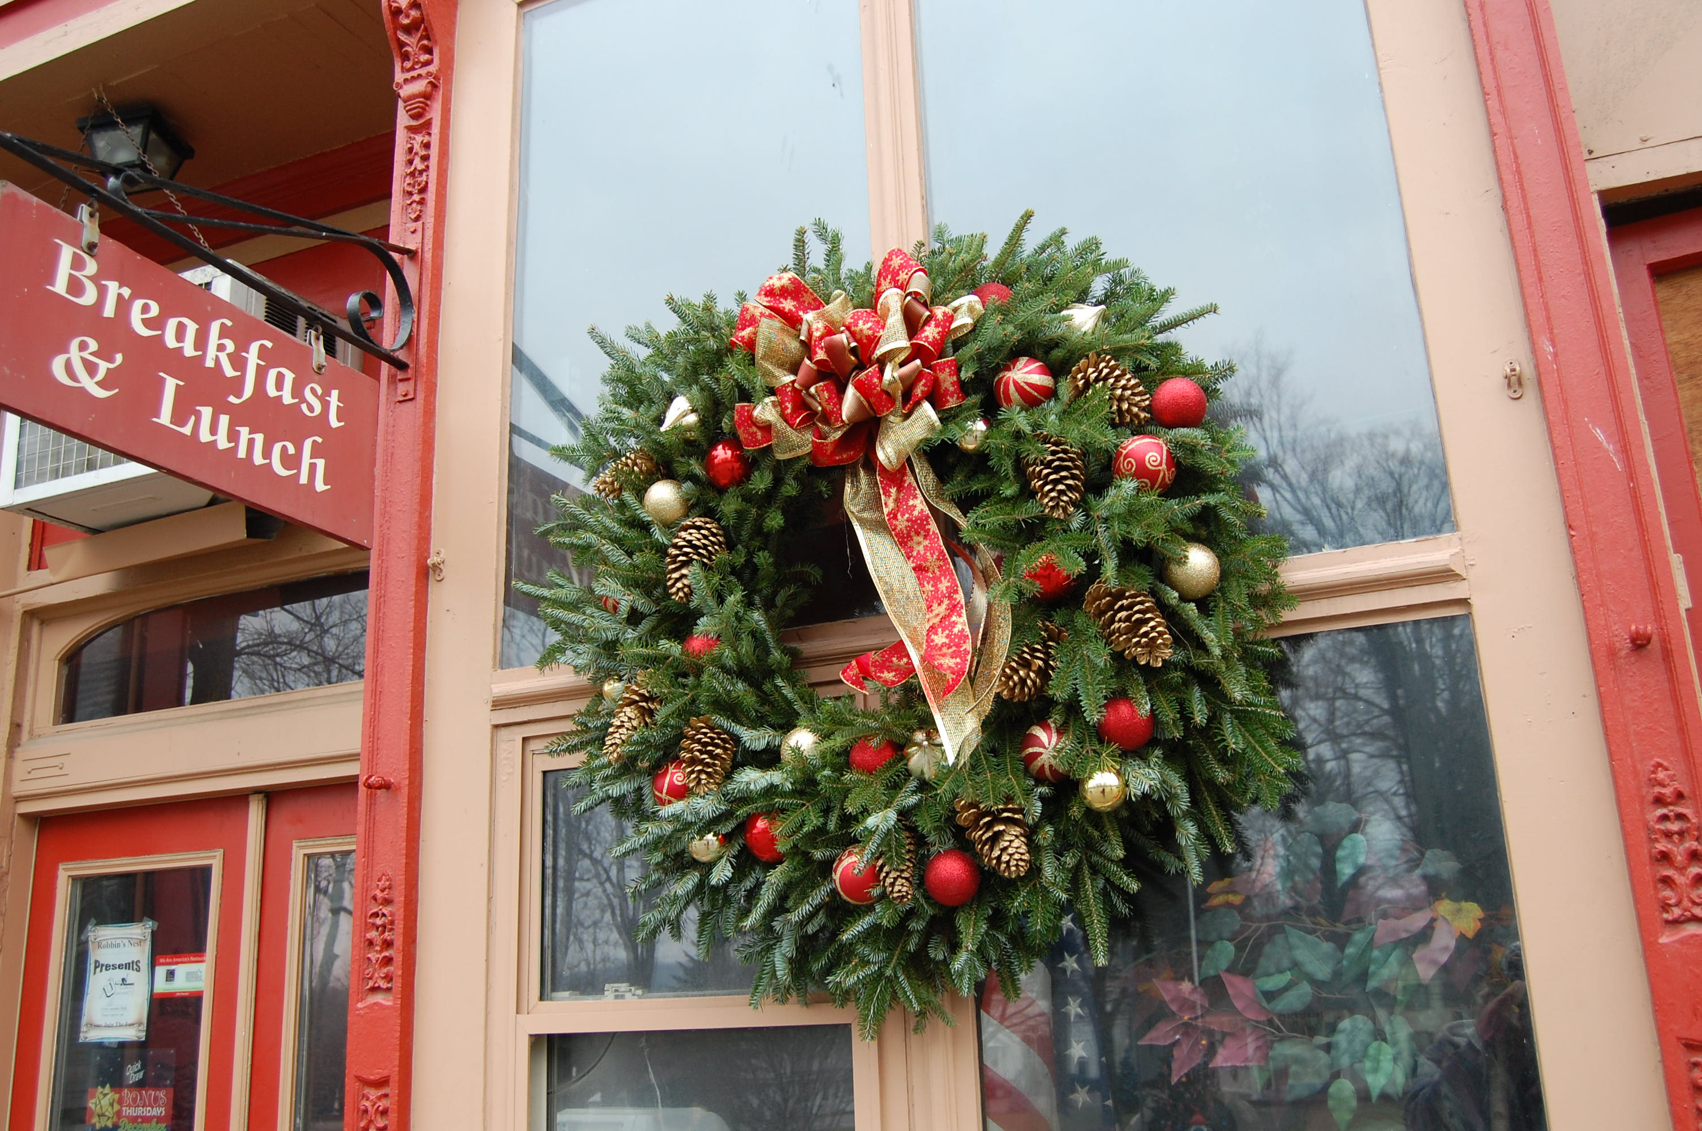 | Local Businesses will have open houses  Friday & Saturday!  Bean Station Tree Farm Kids Coloring Contest! Ages 3-5, 6-9, 10-12  Winners announced on Sunday.  See Facebook page for photos and details  Cookie Walk at Legion Building  Sponsored by Methodist Church  Friday 10-4 Sold by the Pound  Home Basketball Game 5:45pm  Special Music at Robbin’s Nest 9pm-1am
Vote for your Favorite Tree in the Park  with a Non-Perishables Food Item!  Friday and Saturday  All food goes to the Local Food Pantry!  Let’s fill those shelves!  (All trees donated by Bean Station Tree Farm) | 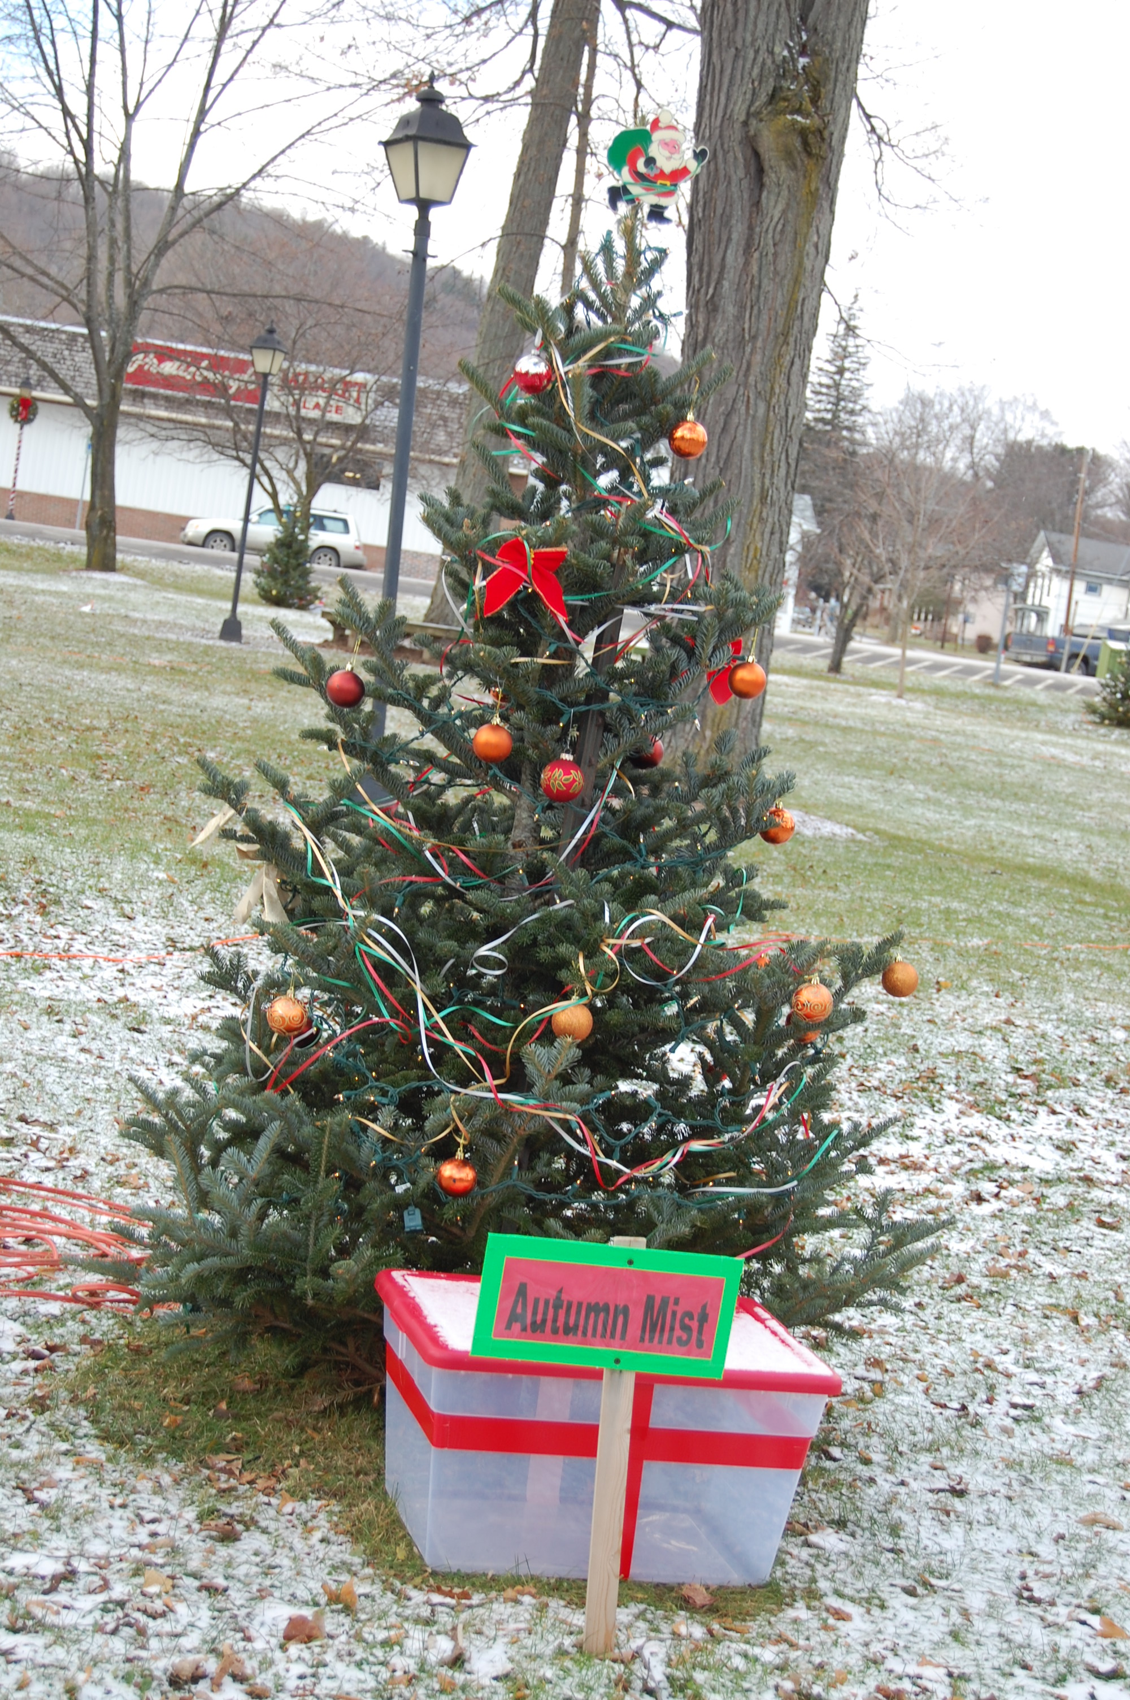
Saturday, December 6th
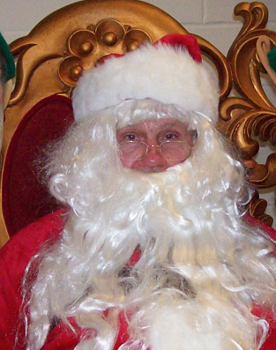 | Rotary’s Annual Pancake Breakfast with Santa  9-11am at the Fire Hall  Photos with Santa, crafts and  All you can eat Pancakes!  $3.00 per person includes all.  Craft Fair at Presbyterian Church  9am - 4pm  Photos of your Pets with Santa  at the Dirty Dog 1-3 pm  $2.00 per dog – donated to ASPCA  Kareoke at Robbin’s Nest from 9pm-1am
Sunday, December 7th
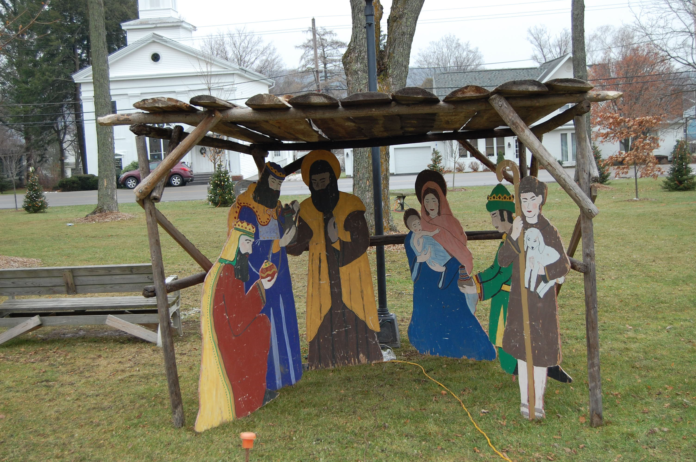  Live Nativity & Tree Lighting  Town Park at 6pm | Victorian Christmas Tea  Hosted by  Historical Society  Serving from 2-4pm  Town Hall  Call 522-3566  $5.00 per person

